Example of the topic “Is love true?” from an early phase in the project. Only a few possible spelling variations of topic words were included. The word bags were filled based on prediction of OCR errors from previous results.

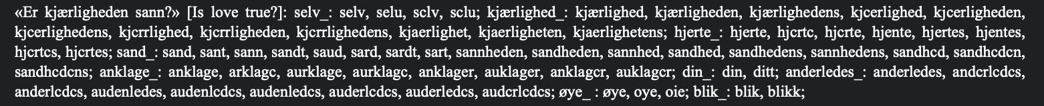

One captured passage from the work Chr. Frich D og Hartvig Halvorsen: *Hvad skal jeg gjøre for at blive salig? : Prædikener over Kirkeaarets nye Evangelietekster* Anden Række (1888)[1]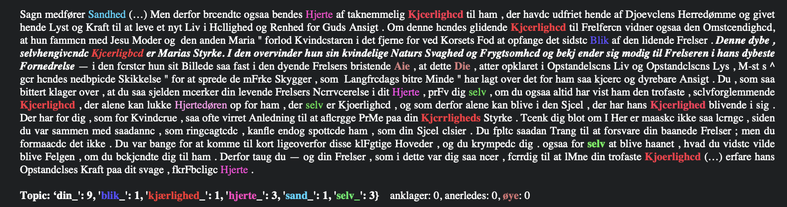 shows that OCR errors occur way beyond these predictions. The algorithm counted “kjærlighed” only once, while it has seven occurrences in the passage:

The wildcard search was born as a result of these observations.

1. The period of study was not yet delimited to 1830-1880.